Revision worksheet

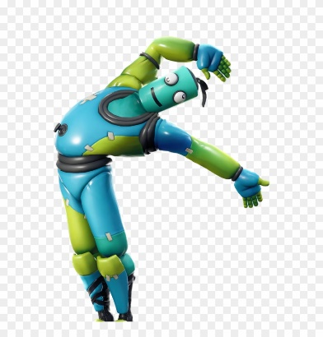**1.- Reorder these words**

a.- is name What your ? ___________________________________________

b.- from you Where are ? _________________________________________

c.- old How you are ? ___________________________________________

d.- do Where you live ? ____________________________________________

**2.- Match the halve**

|  |  |
| --- | --- |
| My name’s | happy today |
| I am | Venezuela |
| I live with | Eleven years old |
| I am from | Juan Carlos |
| I am | My parents and my sister |

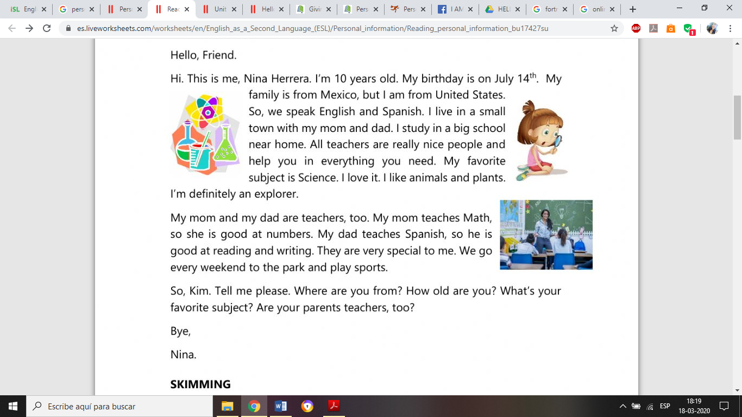3.- Read the text and answer the questions

The text is principally about

a) Nina’s life

b) Nina’s school

c) Nina’s parents

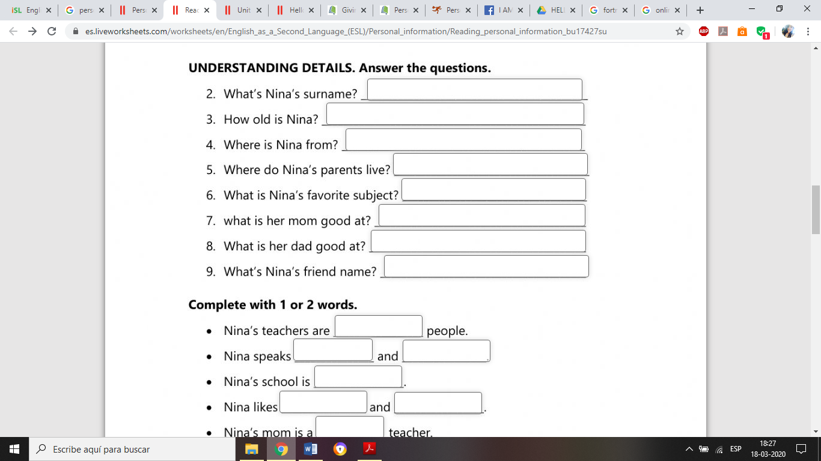

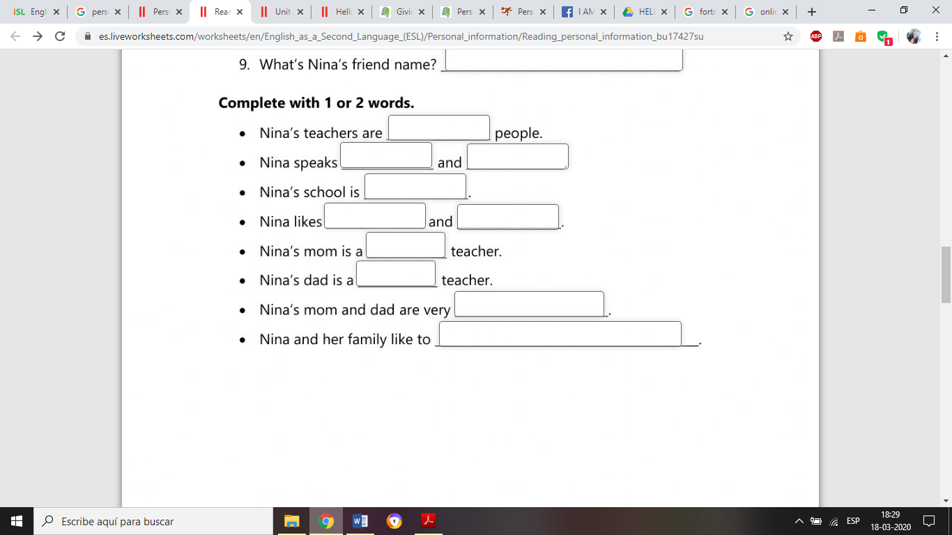

To end this part of the lesson watch this video: <https://www.youtube.com/watch?v=ypGJTW3LRo4>