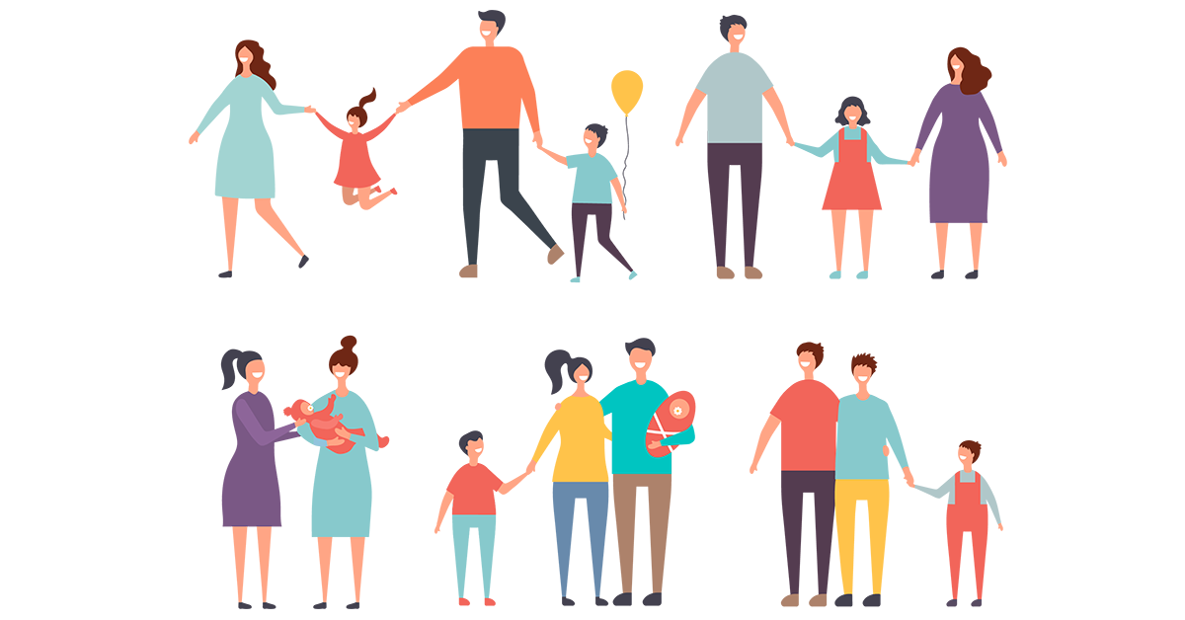Family time

Each family is different but it’s still a family. We are all important.

Let’s find put which members of the family you know.

**FAMILY WORDSEARCH**

**Find the hidden words. Write down the meaning of these words.**

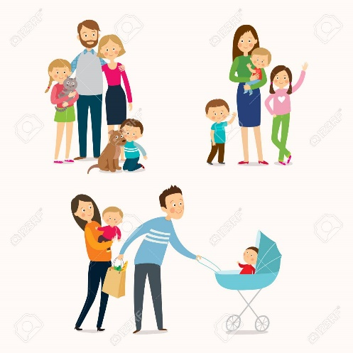

**niece**

**sister**

**uncle**

**wife**

**aunt**

**brother**

**cousin**

**father**

**grandfather**

**grandmother**

**husband**

**mother**

**nephew**

