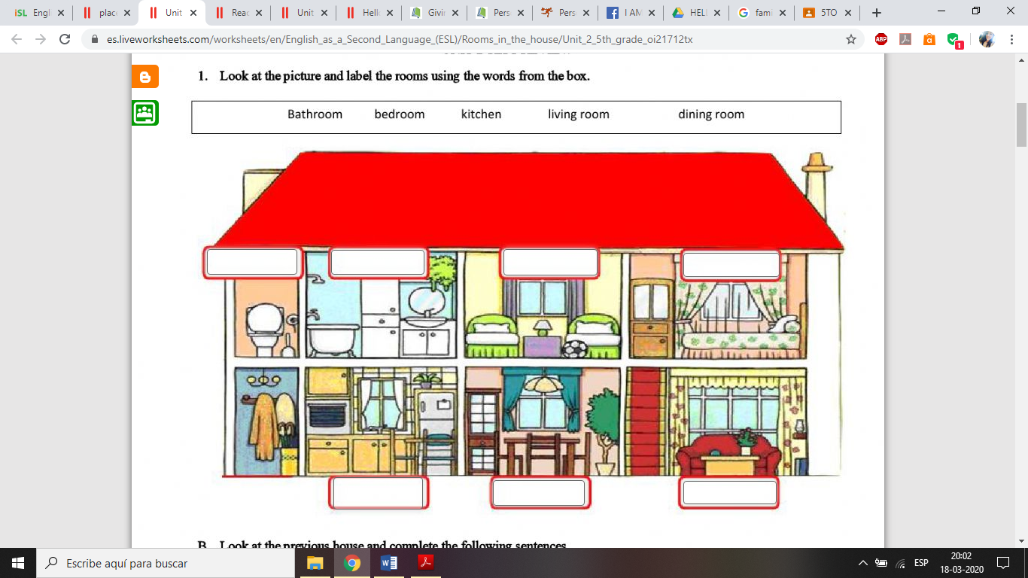 My place, my house

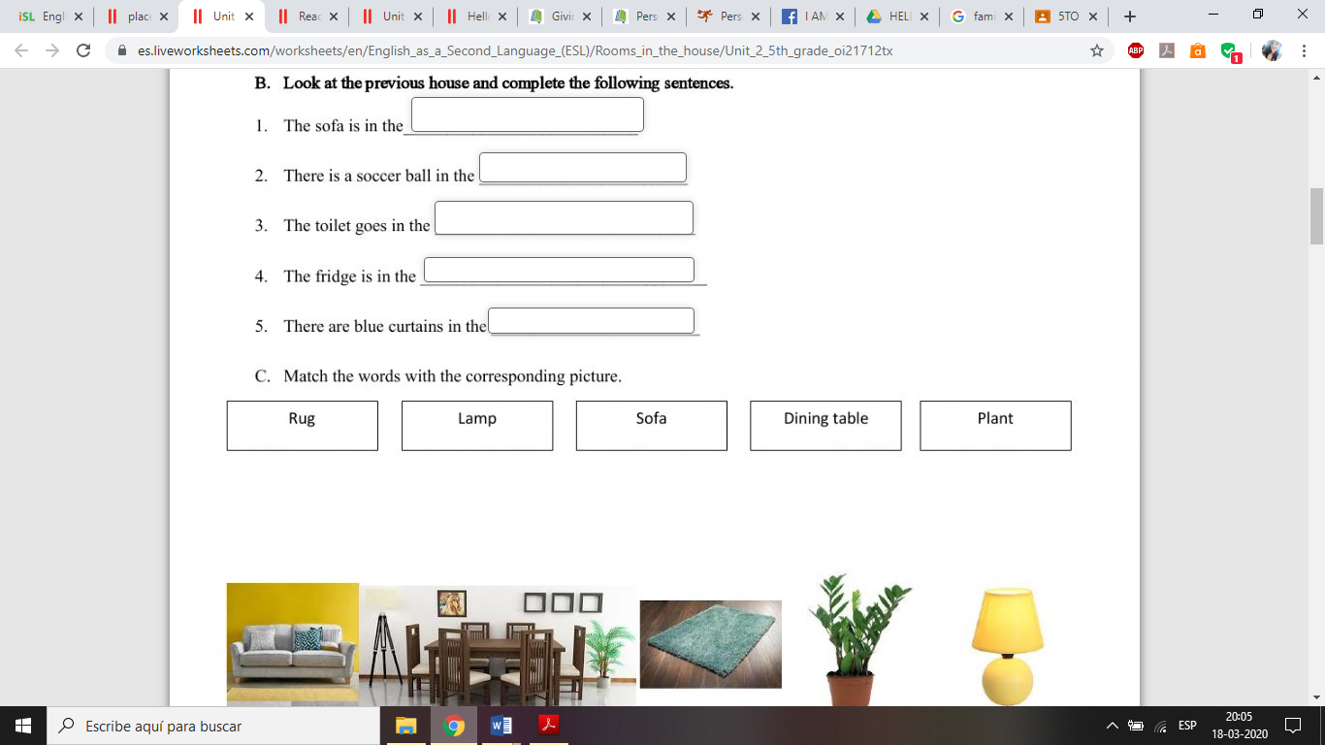

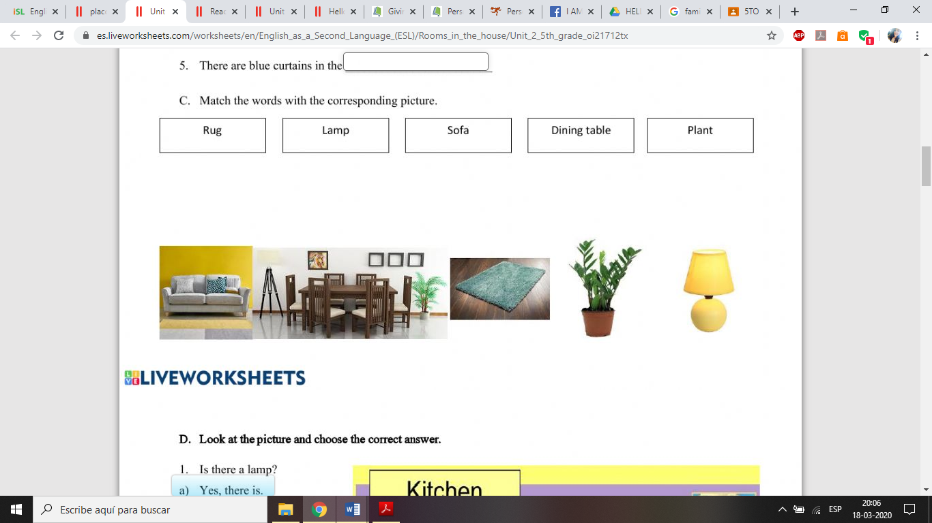

***D.- Label the pictures***

|  |  |  |  |  |
| --- | --- | --- | --- | --- |
|  |  |  |  |  |
|  |  |  |  |  |
|  |  |  |  |  |
| Resultado de imagen para stove clipart |  |  |  |  |
|  |  |  |  |  |
|  |  |  |  |  |
|  |  |  | Resultado de imagen para refrigerator clipart |  |
|  |  |  |  |  |
|  |  |  |  |  |
|  |  |  |  |  |
|  |  |  |  |  |

***E.- Classify the words from exercise A in the correct column.***

|  |  |  |  |  |
| --- | --- | --- | --- | --- |
| **KITCHEN** | **BEDROOM** | **LIVING ROOM** | **DINING ROOM** | **BATHROOM** |
|  |  |  |  |  |

***F.- Match the sentences with the words.***

|  |  |  |
| --- | --- | --- |
| 1. You can **sleep** in here. |  | Living room |
| 1. You can take a **shower** in here. |  | Dining room |
| 1. You can **cook** inhere. |  | Kitchen |
| 1. You can **watch TV** in here. |  | Bedroom |
| 1. You can **plant flowers** in here. |  | Bathroom |
| 1. You can **eat** your dinner in here. |  | Garden |