**Subject:** English. **Date**: Jun 2020

Miss Pamela Zapata

Guide 4 Kinder

**Name:** ____________________________________________________________

Songs about numbers, colors and shapes.

# <https://www.youtube.com/watch?v=Yt8GFgxlITs> (Counting 1 to 10 | Number Songs | PINKFONG Songs for Children)

# <https://www.youtube.com/watch?v=SLZcWGQQsmg> (Canción de los colores del arco iris | Canción inglesa para niños)

<https://www.youtube.com/watch?v=VGDiUaku3bQ> (Dancing shapes)

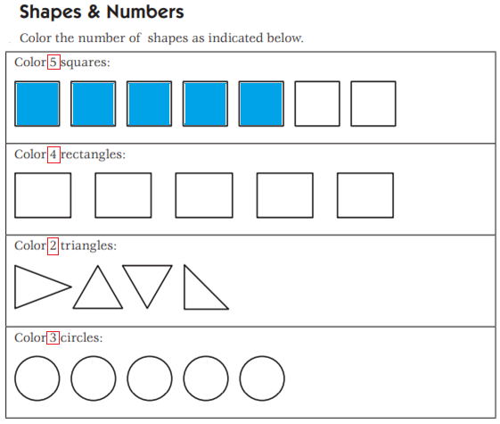

LEER Y UNIR SEGÚN CORRESPONDA.

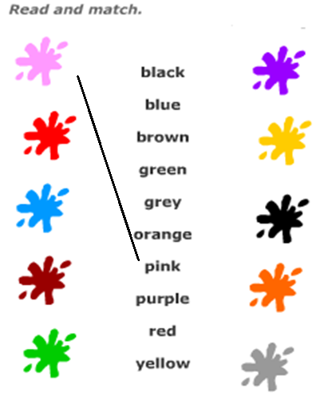

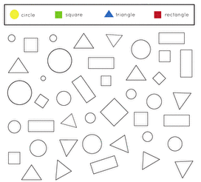**Color and How many…?** (Colorea y cuenta)



HOW MANY ARE THERE? ____



HOW MANY ARE THERE? _____



HOW MANY ARE THERE? _____



HOW MANY ARE THERE? _____