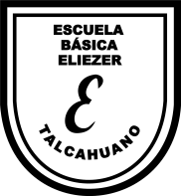**Subject:** English. **Date**: Jun 2020

Miss Pamela Zapata

**Guide 1st Grade (Guide 4)**

**Name:** ___________________________________________________________

**1.- Listen the song about Alphabet.**

The Alphabet Chant | featuring Noodle & Pals | Super Simple Songs

Link: <https://www.youtube.com/watch?v=GS_cGsAnQvQ>

Activity 1.  **Deletrear en inglés las siguientes palabras (Practice with vocabulary about Body parts)**

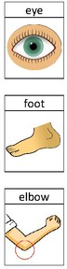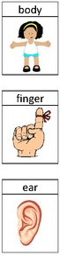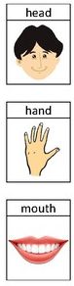**Ejemplo: K N E E KEI - EN - I - I**

**2.- Listen the song about BODY PARTS.**

# Buscar: Hello, My Body!|Body Parts Songs|Pinkfong Songs for Children

# Link: <https://www.youtube.com/watch?v=gS_Mz3ekkck>

* Complementar con actividades de las páginas 16 y 17 del Cuaderno de actividades.

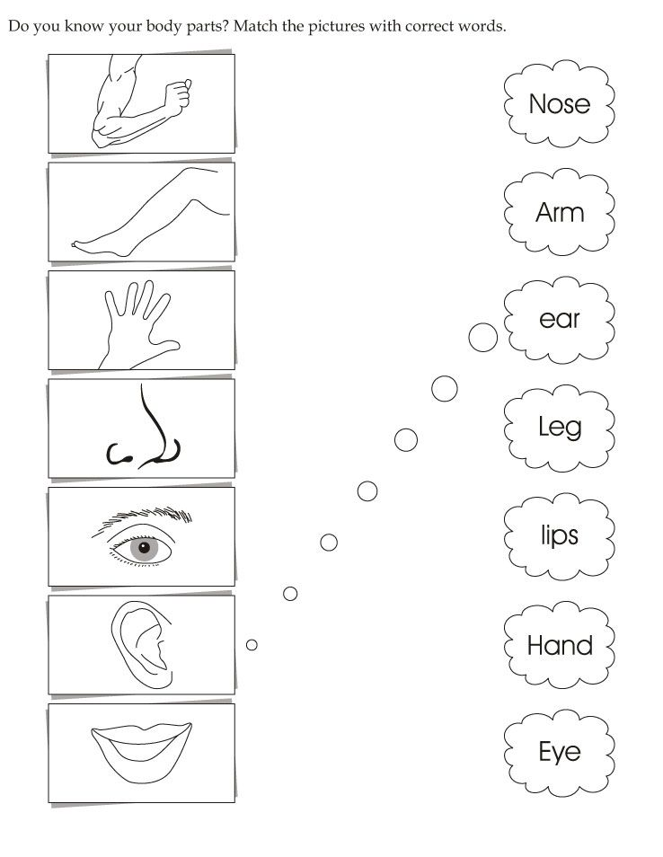Activity 2: Unir

Activity 3: Puzzle about Body Parts

