**Subject:** English. **Date**: September 2020

Miss Pamela Zapata

Guide 6 Kinder

**Name:** ____________________________________________________________

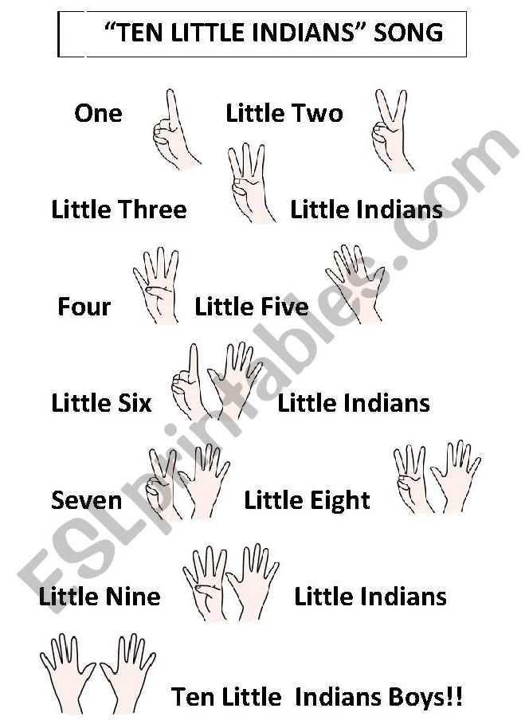1.- Sing a song.

2.- Toys. What is your favourite toy?

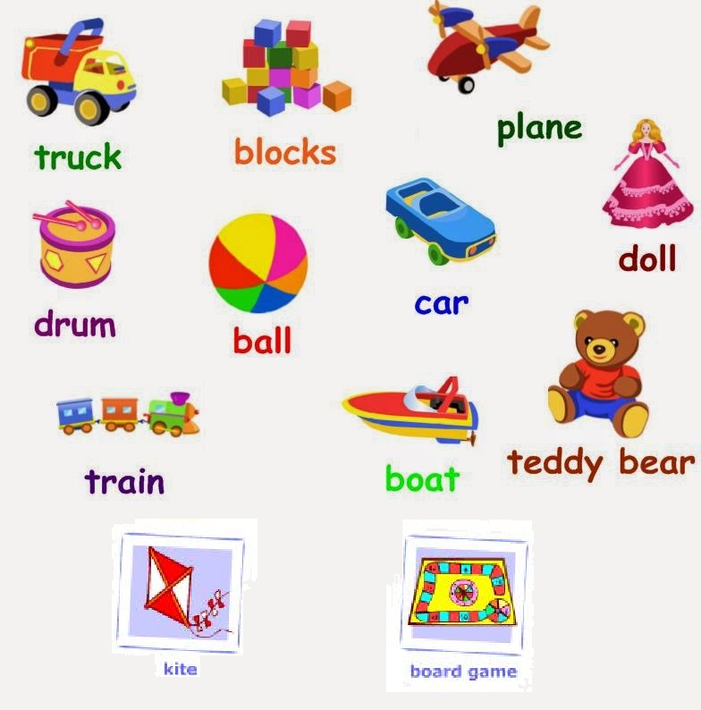(Puppets about toys)

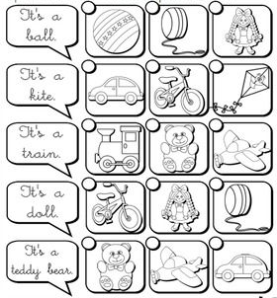Listen and tell me the correct picture.